**IBM NALAYATHIRAN**

**ASSIGNMENT 2**

**TEAM MEMBERS:**

**HARISH A 19C031**

**KOWSANTH KALIDAS R 19C044**

**NAVEEN KARTHIK K 19C059**

**RAJARAJESVARRI G 19C077**

The below given serves as a normal temperature sensor:

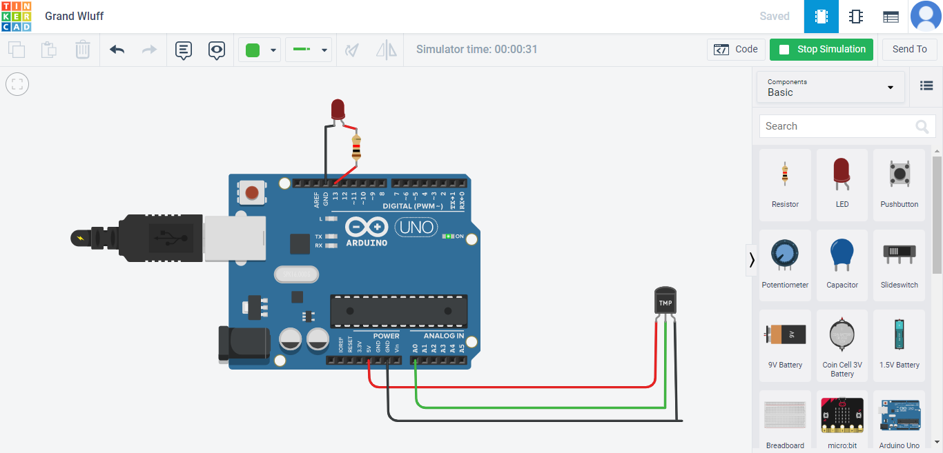

**CODE:**

void setup()

{

Serial.begin(9600);

pinMode(13,OUTPUT);

}

void loop()

{

double a=analogRead(A0);

double t=(((a/1024)*5)-0.5)*100;

Serial.println("temperature sensor");

Serial.println(t);

delay(1000);

if(t>100){

digitalWrite(13,1);

}

else{

digitalWrite(13,0);

delay(1000);

}

}

**OUTPUT:**

